BUCHAN primary SCHOOL NO. 1905



PARENT INFORMATION BOOKLET 2025

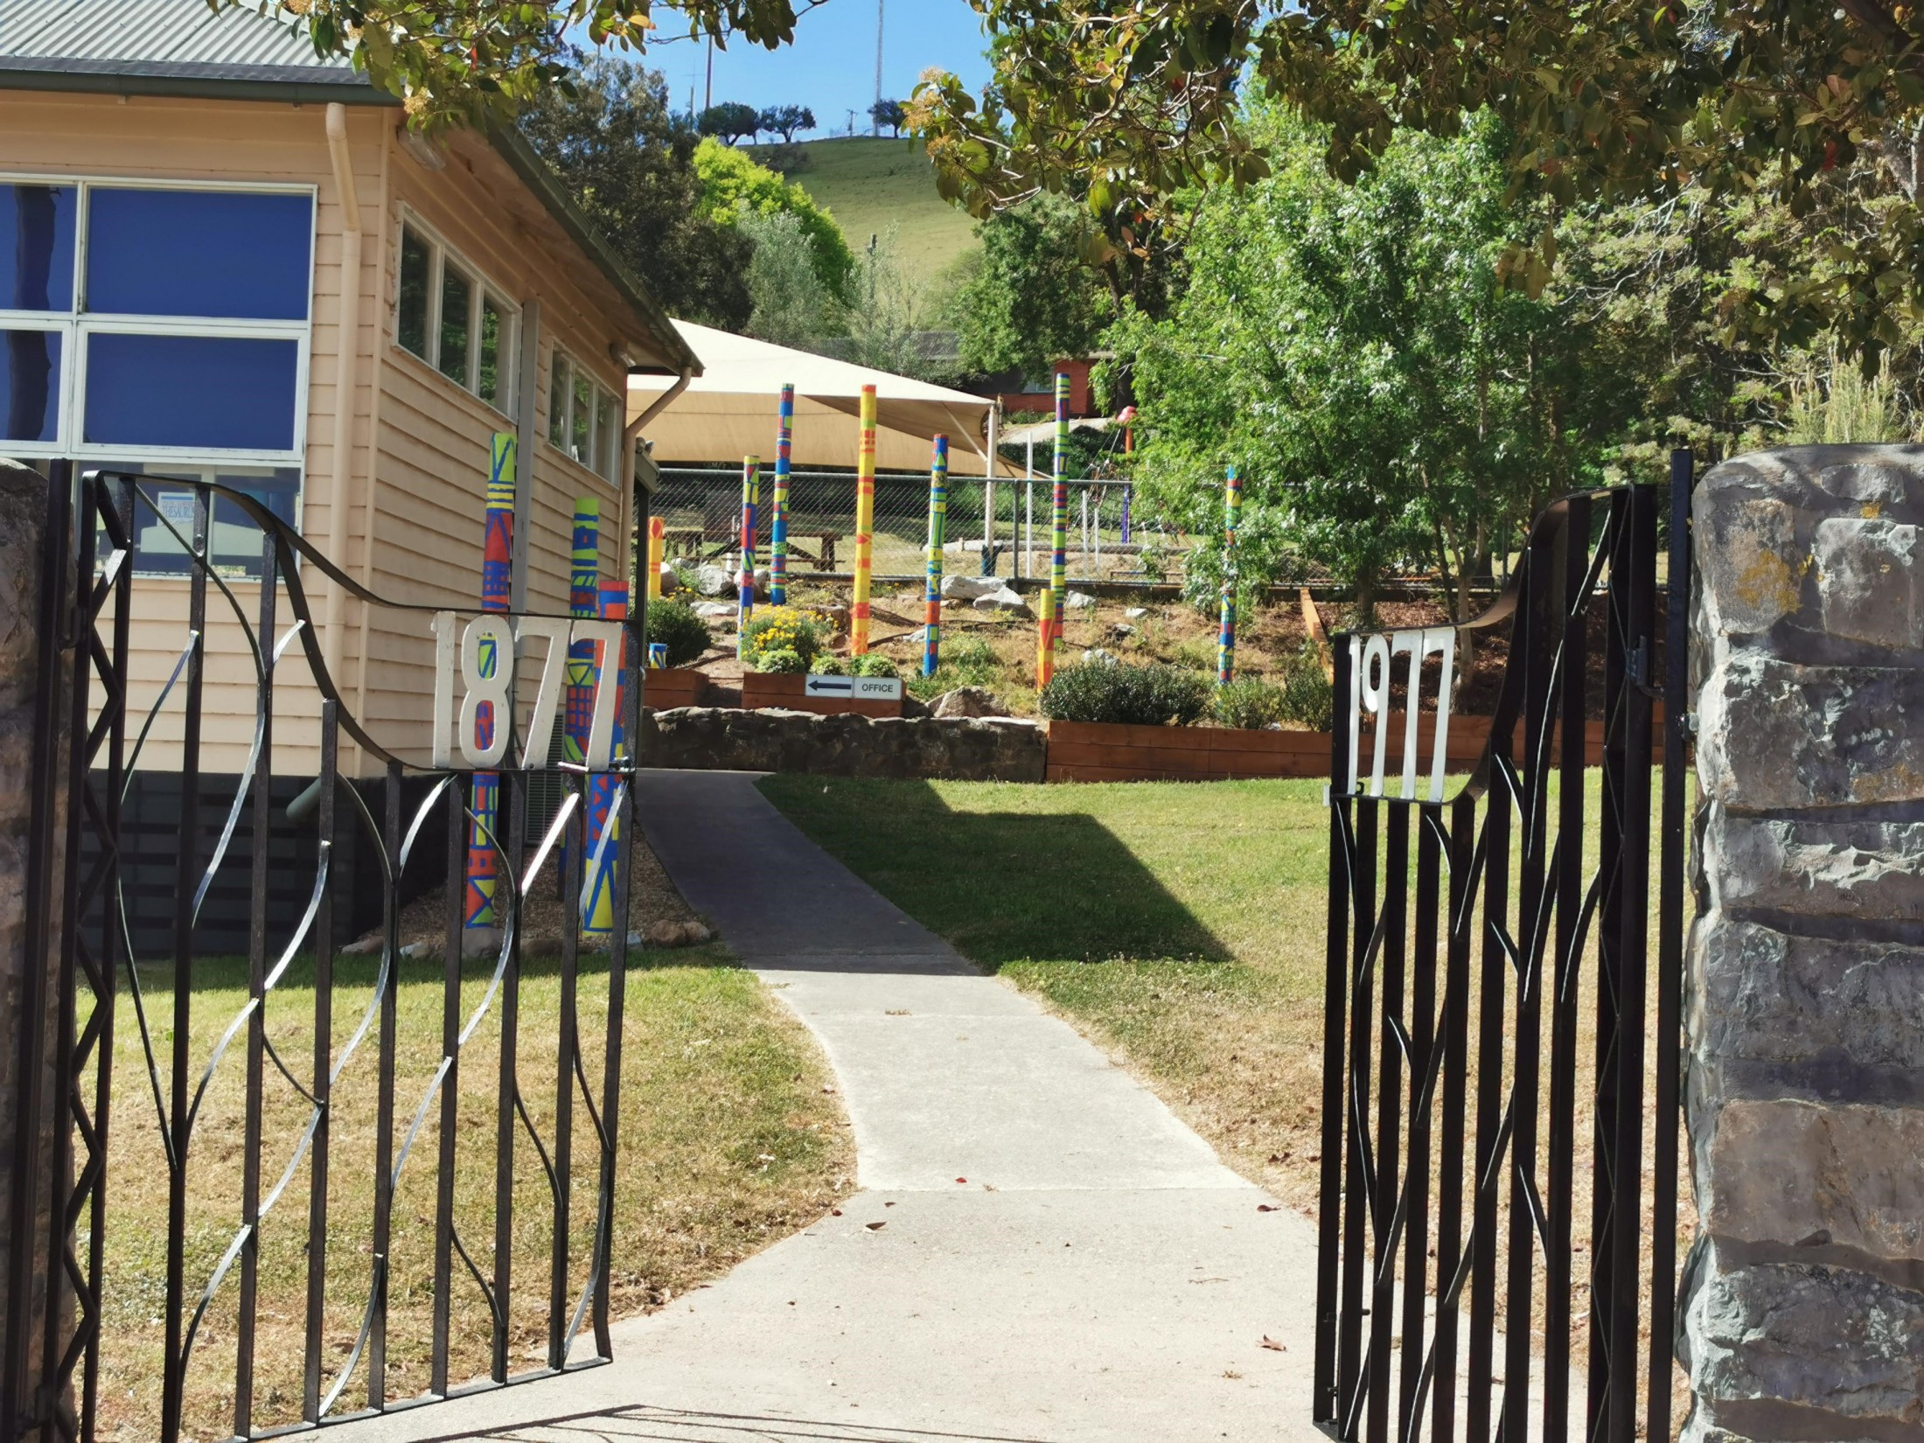

Dear Parents and Carers,

Welcome to Buchan Primary School and thank you for choosing our school to meet your child’s educational, social, emotional and wellbeing needs.

A successful education requires a respectful and positive partnership between school and home. At Buchan Primary School, we place great importance on providing a safe, happy and supportive learning environment for all of our students.

This information booklet reflects our schools current journey and it will be revised at the end of each year to include any further changes that we implement into our school setting to reflect new initiatives and programs.

We welcome your participation in your child’s educational journey and we look forward to working with you, to ensure your child has an enriching and successful experience at our school.

Please do not hesitate to contact us if there are any matters you would like to further discuss.

Kindest regards,

Aidan Johnston Sophie Sandy Business Manager
Acting Principal School Council President Julie Cameron

.

SCHOOL VISION:
Buchan Primary School strives to maximize every student’s wellbeing and learning potential to become lifelong learners and achieve their goals and contribute as global citizens.

SCHOOL MISSION:
Buchan Primary School’s mission is to foster each child’s intellectual, social, emotional and physical development in a welcoming, safe and supportive learning environment.

SCHOOL TERMS:
Term 1 – 28th January to 4th April 2025.
Term 2 – 22nd April to 4th of July 2025.
Term 3 – 21st of July to 19th of September 2025.
Term 4 – 6th October to 19th December 2025.

SCHOOL TIMES:
Start of the day: 9:00 am.
Morning recess: 11:00 – 11:30am.
Lunch: 1:30 – 2.15pm.
End of the day: 3.15 pm.

ASSEMBLY
Our school assemblies are led by our Grade 6 leaders and occur each Monday, commencing at 9am. All parents are welcome to attend.

FORTNIGHTLY NEWSLETTER:
A hard copy format of the school newsletter is distributed to the eldest child of each family on a Thursday each fortnight. It is also available as an electronic copy on the school website, School Stream and sent to your registered email address. Please visit www.buchanps.vic.edu.au to access this.

PUPIL SUPERVISION BEFORE AND AFTER SCHOOL
Teachers will be on duty between 8.45am to 9am and 3.15 to 3:30pm.
CHILDREN SHOULD NOT BE AT SCHOOL BEFORE 8.30am, unless otherwise arranged.

PLAY LUNCH AND LUNCHES
Students are required to eat their play lunch and lunch on the tables and bench seats in the undercover area before going out to play. Drink bottles are recommended and should contain water only and not cordial, soft drinks or energy drinks.
We encourage parents to limit LOLLIES AND PROCESSED FOODS.

SCHOOL VALUES:
Be Kind
Be a Friend
Show Respect
Show Empathy

VICTORIAN MODERN CURSIVE SCRIPT
We have included an example of the cursive script your child will learn on the final page of this booklet. All labelling and lettering done by your child’s teacher will be modelled on this script.

BOOKCLUB
The Scholastic Book Club operates at the school. Children are given the opportunity to order books from a wide selection at reasonable prices and books are to be paid for at the time of ordering.

PARENTAL VISITS TO SCHOOL
Buchan Primary School welcomes parent visits and active involvement in their children’s learning and development. However, it is important to be mindful that teachers and the principal have heavy classroom commitments. To avoid disrupting classroom learning, parents are requested to limit contact and visits to the school to outside class times. Signing in and out of the visitor book is also a requirement if visiting the school.

SCHOOL POLICIES
Buchan Primary School is compliant with VRQA (Victorian Registration and Qualifications Authority). As a government primary school, we are required to comply with a wide range of procedures and regulations, which are reviewed either annually or biannually. Please contact the school business manager or principal if you require further information or copies of specific policies.

SCHOOL UNIFORM
Uniforms are compulsory at Buchan Primary School and can be ordered from Nick’s in Bairnsdale, Julie also holds spares/top ups that are purchasable from school. All students are required to wear hats that protect their face, neck and ears (broad-brimmed or bucket hat), whenever they are outside. This is applicable in Terms 1 and 4. Peak caps and visors are not considered a suitable alternative. Please note: The school does not take responsibility for clothing that is lost or not clearly labelled.
Parents are reminded to clearly LABEL all removable items of clothing. All non-labelled clothing not collected by the end of each term will be washed and utilised as spares and/or donated to families as the principal sees fit. Please note that the school has a uniform policy and a Sun Smart policy in place.

ATTENDANCE
It is compulsory for a note of explanation from the parent to the teacher to be provided if a child has been absent or late from school. Attendance roles are taken on a daily basis and are required to be recorded on the Department of Education systems for reporting and tracking purposes.
Parents / Guardians are asked to notify the school if their child is absent, either on the day due to illness or in advance for family holidays. If an absence remains unexplained after 9.30am on the day of absence, parents will receive an sms to ensure that families are aware their child has not arrived at school, so their safely can be established it is not purely to identify the reason for absence. If your child contracts a serious or contagious infection, please notify the school office by telephone; and if required we will then notify the school community.

STUDENT SUPPORT SERVICES
Buchan Primary School aims to support the health and wellbeing of all students. The following allied health service providers can be arranged to support families as the need arises;
- School Nurse – Prep screening for general wellbeing, hearing and vision.
- Bush Nurse - General health matters, available through the Buchan Bush Nursing Centre.
- Psychologist and Counsellor – available by appointment.
- Social Worker – available by appointment.
- Speech Therapist – available by appointment.
- Occupational Therapist – available by appointment.
SCHOOL STREAM APP
School Stream is our primary parent communication tool for day-to-day operational matters, up and coming events, notices and notifications.

SCHOOL CROSSING
Whilst the crossing flags are displayed before school, the school crossing is not supervised in the mornings. Staff put out the crossing flags in the morning before school and leave them out until the end of the day. Staff dismiss children on the ramp outside the senior classroom, before they man the school crossing and cross the road with the students and retrieve the crossing flags at the end of the day.

EMERGENCY MANAGEMENT
The school has a comprehensive emergency management plan which is linked to relevant state agencies. In the event of an emergency situation that affects school operations such as floods or bushfire, parents who have an active mobile phone number will be informed of an emergency or major event situation through an SMS, School Stream or phone call where possible. Alternatively, parents can get current information from local radio and emergency services websites. Emergency Drills are necessary for the safety of all those within the building and they are conducted every term to ensure all are familiar with the routine.

BUSHFIRE AT-RISK REGISTER (BARR)
Buchan Primary School is categorised as a BARR school. Inclusion on this register is a trigger for the school and kindergarten to pre-emptively close on days the district is declared Code Red by the Bureau of Meteorology. Associated protocols will be enforced on these days and this school will be closed and unstaffed. Bus travel will also be cancelled. Please request further information from the school in relation to this matter.

STUDENT FREE DAYS
There are 4 scheduled student free days throughout the year. This allows staff time for professional development opportunities outside the school. The school is not able to provide care for children on these days. These dates are generally set early in the year and parents will be notified through our newsletter. Please watch the newsletter for reminders of these dates.

LIBRARY BOOKS
Being literate is an essential life skill. To support this, at Buchan Primary School, children have access to borrow books from THREE library services on a regular basis.

- School Library
  - Classroom teachers incorporate library skills into their learning programs as required.
  - School Library books can be identified by the Buchan School stamp inside the front cover.
- Shire Library Bus
  - The East Gippsland Shire provides a fortnightly borrowing service in a mobile van, which parks outside the school crossing. Teachers supervise their classes who use this service and membership forms can be collected from the bus coordinator and once filled out, all students are given a membership card.
  - Shire Library books can be identified by the fluro orange shire sticker.
- MARC Van
  - As part of the TUBBS small schools cluster, Buchan Primary School accesses fortnightly visits through the Mobile Area Resource Centre (MARC). The van and accompanying teacher, deliver literacy-based lessons in classrooms allowing teachers planning, assessment and meeting time.
  - MARC Van books can be identified by their yellow van stickers.

Children need a book bag when borrowing books to protect them.

TUBBS CLUSTER OF SCHOOLS
We access a range of social, learning and sporting opportunities through our involvement in the TUBBS cluster of schools. We work together with local primary schools to provide our students with access to:
- Sporting Opportunities: Swimming Sports, Athletics, Cross Country (Buchan Primary School organises this event), winter and summer sports.
- Performing and Visual Arts: Workshops and theatre performances.
- Outdoor Education: Our Grades 3-6 camping program is organised by the TUBBS cluster of schools. Our children attend camps with their fellow TUBBS schools, which provides our children with the opportunity to broaden their social networks.

SCHOOL WELLBEING DOG
We have a cavoodle well-being dog called Marley who is part of our school community. We use ‘Dogs Connect’ to provide support and training for her. The responsibility of looking after the dog is shared between staff.

AMBULANCE SUBSCRIPTION
An Ambulance Family Subscription is recommended, because if it is deemed a student needs an ambulance, one will be called, and parents will be contacted.

VICTORIAN CURRICULUM
At Buchan Primary School we implement the Victorian Curriculum. Our ultimate aim is to ensure each and every student is provided with high quality teaching and learning programs that engage them at their individual point of ‘learning need’ rather than their age or year level. To do this, teachers at the school implement a differentiated curriculum that better caters for individual students and their personal needs and abilities, regardless of their grade level.
The Victorian Curriculum F–10 sets out what every student should learn during their first eleven years of schooling. The curriculum is the common set of knowledge and skills required by students for life-long learning, social development and active and informed citizenship. The Victorian Curriculum F–10 incorporates the Australian Curriculum and reflects Victorian priorities and standards. Schools may specialise in or offer various learning areas based on their staffing profile and capacity each year.
The Victorian Curriculum is broken into the learning areas and capabilities, most levels of which are assessed over a two year period:
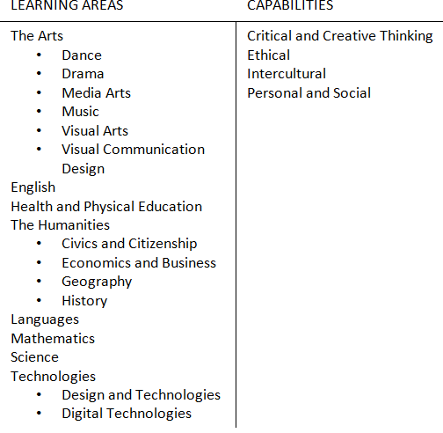
Students are assessed against a range of progression points related to the Victorian Curriculum standards. A mid and end of year report is provided to parents, as well as an interim report in Terms 1 and 3. Parent and teacher interviews occur in Terms 1 and 3 and student led conferences occur in Terms 2 and 4. Further discussions and follow upcan be arranged at any stage throughout the year.
ADMINISTRATION – PAYMENTS AND PERMISSION NOTICES
Please address general enquiries to our Business Manager Julie Cameron who works 2 days per week (Tuesday and Thursday in 2025).

ASTHMA
Students requiring Ventolin or other asthma medication must be listed on the school’s asthma register and must have their space and Ventolin clearly labelled and kept in their school bag or on them. Asthmas Action Plans need to be completed by the child’s doctor. Parents are contacted when a child suffers a severe asthma attack.

COMMUNICATION
There is a range of methods we use to communicate with our school community:
- The school newsletter which covers a whole range of school events. This is published and handed out to the oldest in the family fortnightly each Thursday.
- Activity notices regarding specific events and activities will be given to each child which will require parent approval. Parents can also sign forms online using e-signature on the School Stream app.
- School website – www.buchanps.vic.edu.au
Here you can find a wealth of information about our school.
- Parent / teacher conferences. At the beginning of each term our teachers will provide you with information which involves a summary of key events for the forthcoming term.
- Messenger on the School Stream app. You will be contacted if your child appears unhappy, is experiencing specific difficulties in areas of learning, behaviour, social or emotional adjustment, of if there is any indication of hearing, visual, speech or physical difficulty. Likewise we encourage parents to notify the school if you feel your child may be experiencing difficulty. It is advisable to arrange a mutually convenient time if you would like to discuss your child’s needs in detail, as teachers are not able to leave students unsupervised whilst speaking to parents.
- Once parents have contacted the school regarding enrolment, ongoing informal communications are encouraged at Buchan Primary School.

INJUIRES AND FIRST AID
Injuries are assessed by staff who hold current First Aid certificates. Parents or emergency contacts are immediately contacted regarding suspected fractures or serious injuries to the head or eyes. A written illness / injury parent notification form is completed for students treated for first aid regardless of the severity of the injury. Students are given a copy of this form to take home.

WELFARE / WELLBEING ISSUES
The class teacher is the first point of contact at the school. If you have a concern regarding a wider school issue, please contact the principal.

MEDICAL CONDITIONS
Please indicate on the enrolment form if your child suffers from asthma, epilepsy, diabetes, food or other allergies e.g., allergy to bee or wasp stings or anaphylaxis. If your child is under ongoing medical, hospital or specialist care and there is a risk of sudden illness, please notify the teacher or the principal. Every student who has a medical condition or illness should have an individual written management plan from their doctor.

ANAPHYLAXIS
Buchan Primary School has processes and procedures in place to support students diagnosed as being at risk of suffering from anaphylaxis. This includes a policy that is compliant with Ministerial Order 706 and the Department’s guidelines for anaphylaxis management. This policy applies to all staff, including casual relief staff and volunteers, all students who have been diagnosed with anaphylaxis or may require emergency treatment for an anaphylactic reaction, and their parents and carers.

HEALTH
Remember that infections spread quickly at school. A SICK CHILD SHOULD BE KEPT AT HOME! The school does not have facilities, nor do the teachers have the time to provide ongoing monitoring and care for a sick child.

MEDICATION
School staff are not able to administer analgesics, such as drugs containing paracetamol or aspirin – this includes Panadol, Nurofen and other similar medication available over the counter from a pharmacy. (Analgesics can mask signs and symptoms of serious illness and injury).
If a student requires prescription medication to be administered at school, please consider first if the medication can be taken outside the school day, for example medication required three times a day may be able to be taken before and after school and before bed.
Any medication to be administered at school must conform to all of the following requirements, and be handed into the school office.
- In the original medication bottle or container.
- Clearly labelled – including the name of the student, dosage and time to be administered.
- Accompanied by a completed and signed by a medical / health practitioner or parent a Medication Authority Form. Never leave medication (Other than Ventolin) in a child’s school bag.

HEAD LICE
Infestation appears from time to time. A notice is sent out to all parents if there are suspected cases of head lice in a class or if a parent advises the school about head lice. Untreated, the problem can reach epidemic proportions and if you detect head lice on your child’s head, contact the school immediately and treat it. Various treatments are available at pharmacies and the child must begin treatment before returning to school. If you require any further information regarding detection and treatment procedures then please refer to www.health.vic.gov.au/headlice

LOST PROPERTY
Lost property is located in a tub at the end of the main corridor hallway. All items found around the school are placed here at the end of the day if there is no name on them and this includes uniform, lunch boxes, drink bottles etc. Items of high value are handed in the school office.

LATE ARRIVAL / EARLY DISMISSAL
Students are expected to arrive at school between 8.45 and 8.50 and be collected by 3.15pm at the latest. Staff supervise the yard from 8.45 am, at recess, lunch time and until 3.15pm. If your child arrives late to school for any reason (Any time after 9am), please sign your child in at the office. If your child is to leave school please sign your child out at the office. If your child is not collected from school after 4pm and no arrangements have been put in place and we are unable to contact your emergency contact, then the police and or Department of Human Services will be contacted to arrange care of the student.

STUDENT SUBJECT CONTRIBUTIONS
Student contributions are decided by the School Council for each school year and these payments are voluntary. Payment options are sent out in December with payment due in Term 1 of the next school year. Payment plans for student contributions are available on request – please contact our Business Manager for further details.
The following areas are covered through parent supported contributions: Curriculum materials, excursions and programs, sport and swimming and water safety program in Term 4.

WET DAY / HOT DAY TIMETABLES
Students are supervised in classrooms by teachers if it is too wet to play outside or too hot during recess and lunch time.

HOT LUNCH
Children can either:
1) Bring their lunch to school - in this case supply a plastic lunch box and drink bottle, CLEARLY NAMED.
2) Order a hot lunch each Thursday which comprises of hot dogs one week and toasted sandwiches the other week.
3) Students have the option to purchase lunch 3 times per term from the Buchan Roadhouse as an added alternative.

PARENT COMPLAINTS PROCEDURES
The DET (Department of Education and Training) is committed to treating everyone with dignity and respect and encourages good communication between parents and schools.
Schools need to know if you have any concerns about your child’s education. Teaching and learning works best when parents and teachers talk to each other and work together to solve any problems. DET parent complaints procedures can be found at http://www.education.vic.gov.au/about/content/Pages/complainschool.aspx

PARENT PARTICIPATION IN THE SCHOOL
There are many ways you can volunteer your time at Buchan Primary School and your involvement in any way is appreciated by the staff and students. Some of the ways you can be involved include:
- Working bees (This happens each term).
- School Council representative.
- Helping on excursions.
- Assisting in the classroom.

SPECIALIST SUBJECTS
The specialist subject students engage in are the following; The Arts (Art, music, drama and pottery), Physical Education, LOTE languages other than English (AUSLAN), Mindfulness, Outdoor Education, STEM, ICT and Environmental play.

STUDENT REPORTING
The school has a thorough reporting process that is aimed to keep parents and students informed of their child's academic, social, emotional and wellbeing progress at our school.
Early in Term 1, parent and teacher conferences take place to inform parents of the following: Student learning strengths and weaknesses, raise any early academic, social, and emotional and or wellbeing concerns. A brief overview of the term is also discussed. Individual learning plans are discussed and implemented if applicable.
During Term 2 student led conferences take place. Students learning strengths, areas for improvement and learning goals are discussed, as well as a brief overview of the term. Individual learning plans are discussed and implemented if applicable. Semester 1 reports are sent home in the last week of school.
Early in Term 3, parent and teacher conferences take place to inform parents of the following: Student learning strengths and areas for improvement and an opportunity to raise any early academic, social, and emotional and or wellbeing concerns. A brief overview of the term is also discussed. Individual learning plans are discussed and implemented if applicable.
During Term 4 student led conferences take place. Students learning strengths, areas for improvement and learning goals are discussed, as well as a brief overview of the term. Individual learning plans are discussed and implemented if applicable. Semester 2 reports are sent home in the last week of school.

Of course, teachers are always available to chat to parents about any concerns they may have or if they wish to raise any issues.

COOLING, HEATING AND AIR PURIFERS IN CLASSROOMS
All classrooms have heaters and air conditioning for added comfort, as well as air purifiers.

PARKING
Please note that the parking area (outside the principal’s office) on the west side of the school is reserved for people employed at the school. Parents are requested not to deliver and pick up children from this area and instead use the parking area (Service Road) opposite the school crossing. Please observe great care when parked near the crossing and allow the bus to exit first.

SCHOOL PHOTOS
Each year the school offers a school photo service to families. Parents can purchase a whole school photo and or individual or photo packages that suit their needs.

BICYCLES AND SCOOTERS
Please ensure that your child knows the road laws and can ride competently before allowing them to ride to school. Parents must ensure that the bicycle and or scooter is in roadworthy condition.
The school will not be responsible for damage to or theft of any bicycle or scooter if left at the school during school hours and or after school hours.
All children riding bikes and or scooters to school must wear approved crash helmets.
If this rule is not strictly adhered to, the child will be asked to keep his/her bike and or scooter at home for one week.

SCHOOL COUNCIL
Each school has a School Council which is the governing body of the school. The School Council has a number of roles and responsibilities which include:
- Determining the general educational policy, goals and priorities of the school within the framework of the Strategic Plan and Statewide guidelines.
- Developing a Strategic Plan.
- Monitoring and evaluating the performance of the school in relation to the goals and priorities in the strategic plan, including participating in the school review processes.
- Reporting annually to the school community and to the DET.
- Approving and monitoring the school budget (Including school-generated funds) which needs to be consistent with the strategic plan.
- Ensuring that all monies coming into the school budget (Including school generated funds) are consistent with the strategic plan.
- Ensuring that all monies coming into the hands of School Council are expended for proper purposes.
- Developing the Student Code of Conduct.
- Exercising a general oversight of the buildings and grounds, ensuring that they are kept in good order and condition.
- Providing for necessary cleaning and sanitation services.
- General stimulating interest in the school.
The Council meets during school terms and meetings are normally held on the third Monday of each month commencing at 5pm. Council elections are held at the start of each year and the term of office is two years. Information about the elections is sent home early in Term 1.

BUS TRAVEL
Some students may be eligible to travel regularly on the school bus.
Parents of bus travellers are to advise the school (preferably written) of alternative travel arrangements. Please note that regular bus travellers will always be put on the bus unless contact is made by parents.
Should your child not be a registered bus traveller, permission can be granted for them to travel under “adhoc” arrangements on particular occasions. Please contact the school at minimum one day prior to travel. Forms are available at the school office. In accordance with the Department of Education and school policy, adhoc bus travel is bound by conditions and is at the Principal’s discretion. Arrangements for adhoc travel must be made with the school at minimum, one day prior to travel.
Should the parent choose to cancel this arrangement on the day the parent must inform the school and the local bus company of the changes (Gillick’s Bus Company).

EMERGENCY CONTACT INFORMATION
Buchan Primary School keeps Emergency Contact Information on each child in case of an accident or illness. It is the parents’ responsibility to ensure this information is up to date.

Please make sure the school has a current phone number where you can be contacted. If you do not have a telephone, or if both parents work, please make sure that the school has the name and phone number of a contact person. Please notify the school of any change of address, telephone number, doctor or any other important details needed for records.

It should be noted that if a parent or emergency contact cannot be contacted the school will take any action deemed necessary for the welfare of the student. Ambulance cover is desirable as schools are not covered and children may be transported to hospital using this service in an emergency. The school will adopt the policy of calling an ambulance if deemed necessary, regardless of costs.

INFECTIOUS DISEASES

Disease or condition | Exclusion from school | Exclusion of contacts
Chickenpox | Until fully recovered or at  least five days after the  eruption first appears.  Note that some remaining  scabs are not a reason for  continued exclusion. | Any child with an immune  deficiency (eg. Leukaemia)  or receiving chemotherapy  should be excluded for  their own protection.  Otherwise not excluded.
Conjunctivitis  (acute infectious) | Until discharge from eyes  has ceased. | Not excluded.
Diphtheria | Until receipt of a medical  certificate following at least two negative throat swabs, the first not less than 24hrs after finishing a  course of antibiotics and  the other 48hrs later. | Exclude family/household  contact until cleared to  return by the Secretary –DHS.
Giardiasis  (diarrhoea) | Until diarrhoea ceases. | Not excluded.
Hepatitis A  (Infectious Hepatitis) | Until receipt of a medical  certificate of recovery is  received, but not before 7  days after the onset of  jaundice or illness. | Not excluded.
Hepatitis B | Until recovered from acute  attack. | Not excluded.
Impetigo  (School Sores) | Until appropriate treatment  has commenced. Sores on  exposed surfaces must be  covered with a watertight  dressing. | Not excluded.
Leprosy | Until approval to return is  given by the Secretary  DHS. | Not excluded.
Measles | For at least 4 days after  the onset of rash. | Immunised contacts not  excluded.  Non-immunised contacts  should be excluded until 14  days after the first day of  28 appearance of rash in the last case. If non immunised contacts are vaccinated within 72 hrs of their first contact with the first case they may return to school.
Meningococcal  infection | Until adequate carrier  eradication therapy has  been completed. | Not excluded if receiving eradication therapy.
Mumps | For 9 days or until swelling  goes down (whichever is  sooner). | Not excluded.
Parvovirus  (erythema  infectiosum fifth  disease) | Exclusion not necessary. | Not excluded.
Ringworm, Scabies,  Pediculosis (Head  lice) | Re-admit the day after  appropriate treatment has  commenced. | Not excluded.
Pertussis  (Whooping cough) | Exclude the child for 5  days after starting  antibiotic treatment. | Exclude unimmunised  household contacts aged  less than 7 years and close  child care contacts for 14  days after the last  exposure to infection or  until they have taken 5  days of a 10 day course of  antibiotics.
Poliomyelitis | Until at least fourteen days  after onset of illness and  receipt of medical  certificate of recovery from  infection. | Not excluded.
Rotavirus  (diarrhoea) | Until diarrhoea ceases. | Not excluded.
Shigella, Salmonella | Until diarrhoea ceases. | Not excluded.
Streptococcal  infection  (inc. Scarlet fever) | Until the child has received  antibiotic treatment for at  least 24hrs and the child  feels well. | Not excluded.
Trachoma | Until appropriate treatment  has commenced. | Not excluded.
Tuberculosis | Until receipt of a medical  certificate from a health  officer of the Department  of Human Services that the  child is not infectious. | Not excluded.
Typhoid and  Paratyphoid Fevers | Until approval to return  has been given by the  Secretary DHS. | Not excluded unless a  medical health officer or a  health officer of the Department of Human  Services determines  exclusion is necessary.
Worms (Intestinal) | Exclude if diarrhoea  Present. | Not excluded.

